Major revisions in PnET-Succession v.5.0

1. Major canopy layering
   1. The algorithm for canopy layering has apparently been completely broken since v.3.5. It may have always been broken, but it clearly did not work once we forced all of a cohort’s foliage to be in a single major canopy layer (v.3.5).
   2. Similar to the original algorithm, the new algorithm uses the relative difference in woody biomass to assign cohorts to canopy layers, but it now uses a user-defined threshold ratio to determine to which layer each cohort is assigned. If the ratio of two cohorts’ biomass is greater than the threshold, they are assigned to different layers. Thus, more of an absolute difference is required as cohorts get larger. This algorithm assumes that the relative amount of woody biomass of a cohort is a proxy for relative height. Because real cohorts can be reduced in biomass without reduction in canopy height due to individual tree mortality, the layering algorithm uses the cohort’s maximum biomass that it has reached within its life as the value for cohort biomass ratios when determining layering. There is a user-defined limit on the number of layers allowed, which tends to result in more cohorts in the lowest layer because layering is processed from the largest cohort to the smallest. In real-world cases where the foliage of different cohorts is not clearly vertically stratified into multiple canopy layers, then the current model will tend to assign those cohorts to the same layer.
   3. One consequence is that the average biomass, LAI and light attenuation of a single canopy layer can experience shifts when a cohort switches to a different layer or dies. We have not been able to develop an algorithm to prevent this, but maybe one has been developed for other categorical (binned) phenomena. It is believed that such discontinuities are short-lived and also cancel each other out across layers and across landscapes, and so we are moving forward with this approach until a better one is discovered.
   4. Use of the cohort’s maximum biomass as the value for layering calculations eliminated the need for specific rules limiting tree cohorts from being reduced in canopy position due to senescence or partial mortality. Their maximum biomass values will maintain them in a higher canopy position when warranted, and they have the possibility of being overtopped if other cohorts surpass their maximum. We do allow cohorts with a designated “ground” lifeform to be restricted to always being in the lowest canopy layer. We’ve added an optional species parameter that specifies life form with ‘tree’ being the default, and any entry including “ground” subject to limitation in the lowest canopy layer.
2. Light attenuation
   1. The original PnET-Succession canopy algorithm assumed that all cohorts within a canopy layer had completely interleaved foliage (i.e., every cubic meter of a canopy layer had equal amounts of foliage of all cohorts in the layer), and that light attenuation was the sum of attenuation by all cohorts in the layer. When we fixed the discrepancy between PnET-Succession and PnET-II in terms of applying reduction factors to GrossPsn rather than NetPsn, we discovered that not enough light was making it through even a single canopy layer to support adequate photosynthesis for survival.
   2. Assuming completely interleaved foliage was not only computationally complicated, but it also ignored the reality that “crown-shyness” is the norm in natural forests so that there is almost no interleaved foliage in canopies. Furthermore, even if foliage was completely interleaved, summing attenuation by all cohorts would not be appropriate. In reality, canopies of individual trees overlap extremely little, and then only for short amounts of time. Thus, we no longer assume complete foliage overlap of all cohorts within a layer. Instead, we work with the paradigm that tree species cohorts compete for canopy area (2-dimensional) but fill up canopy volume as defined by their species’ MaxLAI. Specifics of this competition are outlined below (SECTION??). LAI for the site is calculated as

)

* 1. Light attenuation through all layers (to ground level) is the sum of attenuation through each canopy layer. This results in more realistic light attenuation through canopy layers.
  2. Similar discontinuity consequences occur when a cohort switches to a different canopy layer.
  3. What about sun angle and shading by adjacent trees? Yes, this approach assumes that such shading will occur equally among all cohorts in the canopy layer, and therefore approximately washes out. A stem model would be required to account for such shading mechanistically, so these assumptions are consistent with other such assumptions made to keep the model tractable at landscape scale. The top canopy layer captures most of its light on the upper surface (not sides), and is less subject to shading because trees tend to be about the same height, while lower canopies capture mostly diffuse light anyway, especially when you assume there are no gaps as is done in LANDIS. The group believes these assumptions are not unreasonable for a landscape model.

1. Should water consumption be modeled with an approach similar to light attenuation?
   1. The group concluded that a bucket model is indeed appropriate.
   2. Belowground tissues are not anywhere near as segregated horizontally or vertically as are leaves. Access to water is mostly determined by species-specific wilting point, which is well modeled in PnET-Succession.
   3. Larger cohorts should have better access to water because they have more below-ground tissue and deeper root systems. In PnET-Succession, the priority of access to water by cohorts is proportional to size (see size assumptions below, section XXX), but there is some stochasticity to water access that gives smaller cohorts the chance to survive normal water stress, causing water to be limiting to some extent for all cohorts over the course of a growing season except under unusually wet conditions.
2. Site-level biomass calculations
   1. PnET models growth, photosynthesis, etc essentially as a single tree species cohort, with no disturbances. As such, this ecophysiology model can make simplifying assumptions with respect to total cohort biomass and cohort size (i.e., more biomass = larger stature). Many simplifying assumptions within PnET are linked to this assumption. Specifically:

Fraction Active Wood: FActiveBiom = EXP(-FrActWd*TotalBiom)

Foliar Biomass: Foliage = TotalBiom*FracFol*FActiveBiom

Biomass Allocation: Allocation = (NSC-(DNSC*FActiveBiom*TotalBiom*cFracBio))

In this example, FrActWd parameter = 0.0005. Graphically, this can be conceptualized in the diagram below:

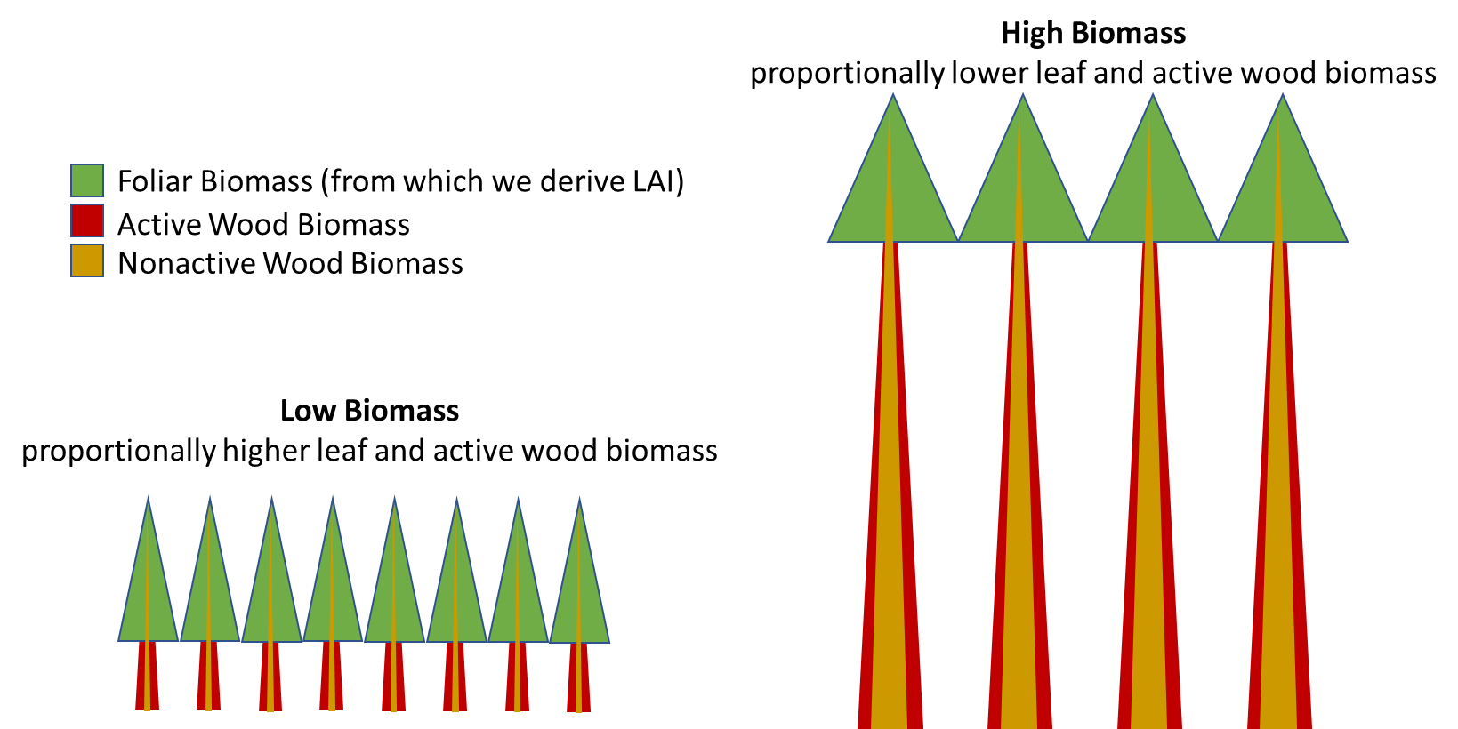

**As soon as you add another cohort, the assumption of size ~ ʄ (biomass) is violated.**

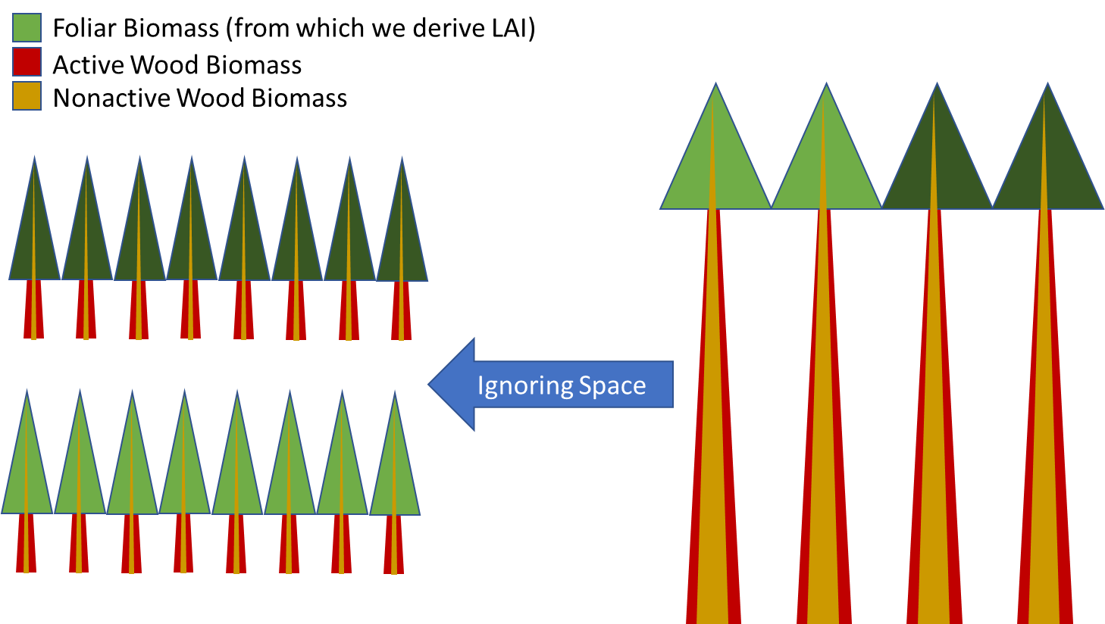

***IF we are to use biomass as a surrogate for size, which is fundamental to PnET, then we need to account for the fact that tree species cohorts cannot physically occupy the same space.***

To enable the breadth of multi-cohort and disturbance processes required of PnET succession within LANDIS-II, we make the following simplifying assumptions:

1. Competition for horizontal (i.e., 2D) canopy space occurs WITHIN a canopy layer.
2. Tree species cohorts compete for horizontal canopy space, but must fill up their 3D canopy volume
3. The proportion of horizontal canopy space for a given LANDIS SITE (cell) a tree species cohort can POTENTIALLY occupy is a function of its calculated potential LAI divided by its maximum LAI.

1. Site Level Canopy Area is modeled relative to the scale of the Cell Resolution. Leaf coverage of a canopy layer can be less than one (i.e., incomplete crown closure), but no greater than 1 complete cell.
   1. Where PCanAreaSite is estimated as >1, the PCanArea of cohorts are constrained to sum to 1, apportioning the canopy space as function of their potential canopy area relative to each other
   2. LAI and Foliage biomass are then back-calculated as a function of the tree-species cohort proportion of canopy area
   3. Site-level LAI is then calculated as the sum of the actual LAI for all tree species in the canopy (i.e., the sum of maximum LAI of tree species cohorts multiplied by their respective proportions of the canopy layer)

1. Given that tree species growth is now constrained by available canopy space (1-4 above),

We also realized that site-level biomass cannot be the sum of each cohort’s biomass density because that assumes that all cohorts simultaneously occupy the same physical space (both vertical and horizontal) on a cell, which is physically impossible. Just as tree canopies within a layer occupy a specific horizontal space within the major canopy layer without sharing that space with others, so the structural infrastructure of trees also cannot physically occupy the same physical space (both horizontal and vertical).

* 1. Given this assumption that cohorts within a layer do not physically share horizontal space, and do not overlap, it seems clear that to represent a site level attribute we must compute a weighted average of the cohort values, and it seems best to use woody biomass as the weighting factor. This method of summarization should apply to all values that are densities (unit/m2) when summarized at the site scale, including all forms of biomass, NSC, LAI, NetPsn, GrossPsn, WoodSenescene, FoliageSenescence, MaintenanceRespiration. Attributes such as Litter, CWD and HeteroResp only have site-level values and are not cohort-specific, so they don’t need to be averaged.
  2. Even if the need to scale values when summarizing to the site-level is clear, there is still a question about how cohort-level values should be reported. For example, a cohort with 1000 g/m2 biomass represents a different total biomass if it is assumed to fill the whole site than if assumed to be occupying only a portion of that site. So should we report its biomass scaled to how much of the site it occupies? It depends on the population that we are trying to describe with the value. Is the question: 1) What is the biomass density of the sugar maple on this site?  Or 2) What is the biomass density attributed to sugar maple of this site? If we were field sampling to answer the first question, we would only sample sugar maple trees and perhaps find that sugar maple has an average density of 1000 g/m2. To answer the second question, we would randomly sample locations in the site and wherever there was no sugar maple the biomass density would be measured as 0. If the site had two species cohorts of equal biomass, we would say the site has an average density of 500 g/m2 attributed to sugar maple. Either one of these approaches is valid, but each describes a different population of interest.
  3. It seems useful to align the cohort-level values that we use within the model and report in the cohort outputs with option 1, where we want to describe the attributes of the cohorts where they exist. But the site-level values that we calculate and report in the site outputs align with option 2, where we want to describe what is representative of the site as a whole. Presenting these outputs in this way, where cohort values are not weighted and site values are weighted, will result in values that appear inconsistent in different types of outputs if not considered in this context. And how the values should be compared to empirical data will also differ between these sets of values. Consequently, it will be important, and challenging, to make this distinction clear to model users.
  4. We are currently testing the option 2 approach to compute cell-level biomass as the weighted average (by biomass) of the biomass density of the cohorts in each canopy layer, and then summing those averages across all major canopy layers to get cell-level total biomass density. Thus, total biomass density in a canopy layer reflects the proportional occupancy of the cell by each constituent cohort. Conceptually, this means that all cohorts in a canopy layer together fully occupy that canopy layer, but an individual cohort does not share horizontal physical space with another cohort within that canopy layer. The total biomass density of the layer is the weighted average of the constituent cohorts’ biomass. Cohorts in one canopy layer can share the same horizontal space with cohorts in a different canopy layer because they are separated vertically. Again, total site biomass density would be the sum of the weighted averages of the cohorts in each canopy layer.
  5. Similar discontinuity consequences occur when a cohort switches to a different canopy layer.

1. Does this approach violate the LANDIS assumption that cohorts are homogeneously distributed across a cell?
   1. This LANDIS assumption implies that the spatial distribution of stems of a cohort is even or random, not clustered.
   2. It does not imply that all cohorts simultaneously occupy the same physical space, which is impossible. It implies that the stems of the cohorts physically occupy some proportion of the cell’s area with a non-clustered distribution, but LANDIS never specifies that proportion.
   3. These algorithms make assumptions to estimate those proportions and applies them to compute realistic estimates of light attenuation and areal estimates of cohort and total biomass.